Changes to IS\LM in Exogenous variables (besides monetary and fiscal policy)
Marginal propensity to save
If Marginal propensity to save increases then S>I (or leakage>injection) for all Y-r combinations and flow of income will as a reaction will fall until S=I
If it MPS increases, marginal propensity to consume decreases .as people consume less, businesses will be unable to spend their goods leading in unplanned accumulation of inventories. This will, in turn, lead businesses to reduce planned investment and production, perhaps also laying people off. Increased unemployment further decreases consumption requiring another round of adjustment, lowering Y still more. Interest rates fall also in a vicious cycle!
The paradox of thrift
Effort from everyone to save more could result in everyone saving less OR higher savings induced by fear of recession could itself cause a recession-a self-fulfilling prophecy
Suppose there is an increase in the efficiency of investment (the marginal productivity of capital). Consider Information Technology: It will bring greater investment so that in I>S which brings a circular flow of income until S=I.
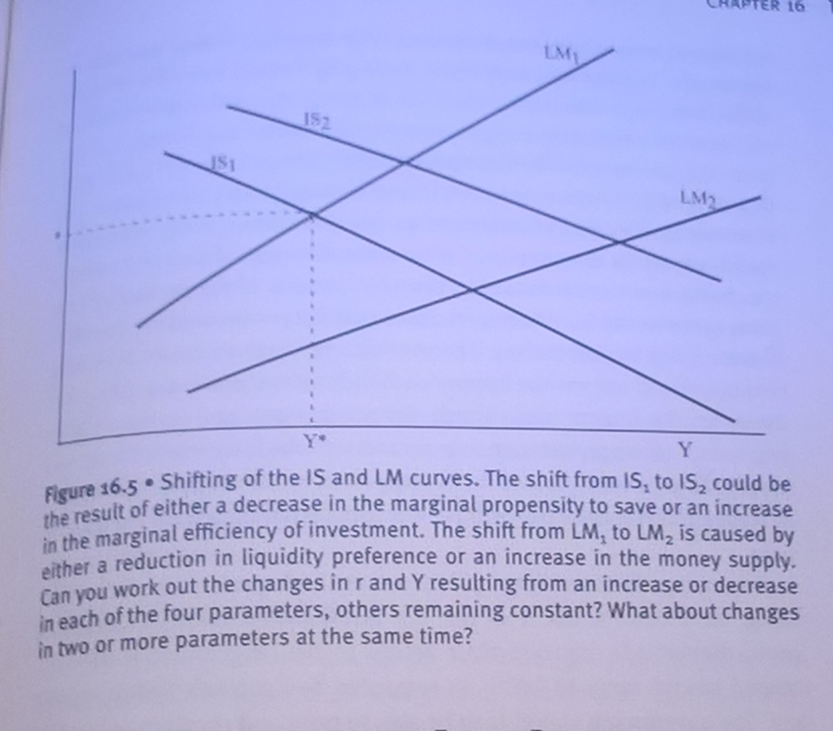
Finally, if liquidity preference increases such as that L>M there will be a resulting uncertainty of future economic conditions where people will seek to be prepared for the unexpected with ‘cash at hand’. Since, it takes a higher r to induce holders of money to lend a new LM (shifted outwards) is needed (with a higher interest rate r* and lower income Y*)

What happens when a lot of changes occur simultaneously?

IS\LM, monetary and fiscal policy
An increase in money supply shifts LM downwards\outwards. That drives interest rates down and Income up as lower rates simulate the economy but if it increased too much there will be too much money chasing too few goods and inflation threatens. Reducing the money supply drives interest rates back up and help control inflation
Fiscal policy is basically government expenditure and taxes. When the government spends money, industry has to produce more goods and services to meet the increased demand. This drives up income and also increases the demand for investments, driving up interest rates. The IS shifts to the right Decreasing spending has the opposite effect
Expenditures may be financed by
- Taxes: When increased, people have less to spend and investment shrinks. However, if government spends the money collected then that effect is offset. Furthermore, some of the amount invested would go to savings have it been left to individual choices.
- Borrowing: Government borrows by selling bonds. An increase in the supply of bonds drives down the price and drives up the interest rate
- Seignorage: printing money may stimulate the economy but will have a countervailing impact on interest rated, again there is the threated of inflation more pronounced.

Soddy’s suggestion was that the government should get entangled in printing and destroying money to balance inflation and, in the same time, chase goals like just optimum scale, just distribution and efficient allocation.
The impact of fiscal and monetary policy depends on how much excess capacity exists in the economy.
Illustration
Consider a bowling alley in a small isolated town where the government is undertaking a large project to stimulate economic growth. When unemployment is high, wages may be fairly low and few people have disposable income to spend on bowling. As a result, the bowling alley will be probably empty. If the government funds a large project in town, some people will be directly employed by the project and they will spend much of their money in town inducing other local businesses to hire to meet the increased demand. People use their extra income to go bowling and the bowling ally’s income grows.
Now, imagine that the government implements the same project in a town with very low unemployment. Bowling is popular and the alley is full every night. The government needs employees for the project but increasing demand when supply is low drives up wages: the price of employees. Disposable income increases but every new bowler at the alley simply crowds out another bowler, who would have to leave the alley. They alley might like to expand, but the government is borrowing money to finance the project, driving up interest rates making it too expensive for the alley owner to expand. The alley may raise its prices with the increased demand but it must also pay higher prices to its labor force and therefore can only break-even.
The failure of lowering interest rated to stimulate economies with low demand is known as a liquidity trap. In reality an economy is somewhere between the two extremes, depression and operation at full capacity (i.e. most bowling alleys are sometimes full, but rarely full all the time). While increased government expenditure leads to some degree of crowding out and increased interest rates, it also increased income -

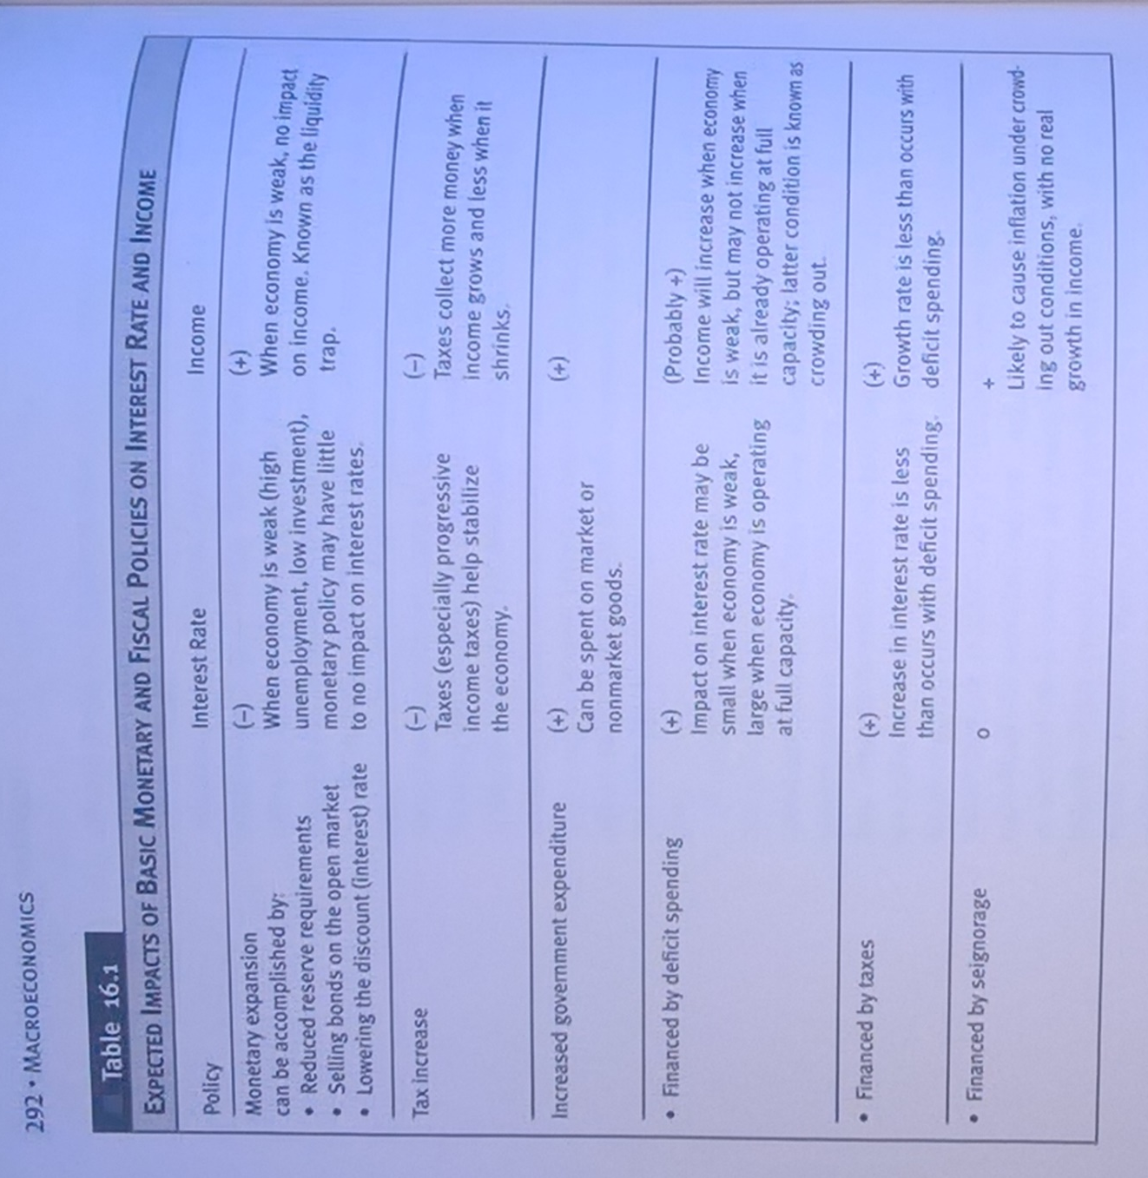
The table shows the effects of monetary and fiscal policy on interest and income. In any case opposite policies lead to opposite impact.

Inflation and Unemployment
If we looked only on the IS\LM model and if our only goal was continued economic growth the policy option would be clear: keep increasing money supply to lower interest rates to stimulate investment, and use fiscal policy when necessary to stimulate demand. However, another way to equilibrium, in response to increase in money supply is price inflation. The closer an economy is to full output; the less output is likely to increase and the more likely it is that inflation will occur instead. People do not like inflation and this justifies that policy makers strive to avoid it. But that is not all; evidence shows that real wages fall substantially during periods of high inflation and furthermore inequality rises as the rich are better equipped to react to inflation. In cases of hyper-inflation, money fails its purpose not only as store of value but also as a medium of exchange.
Impacts of moderate inflation depend on if it is expected or unexpected. If everyone expects a rate of inflation, when it comes to pass, is already incorporated in contracts and cause little problems except for holders of money that pays no interest and people on fixed income. Unexpected inflation, disinflation and deflation have different outcomes that expected inflation. To asses these impacts one should look at the division between debtors and creditors:
When there is unexpected inflation any loans on fixed (nominal, not pegged to inflation) interest rate will favor debtors. In 1960’s people would get 30-year house mortgage at 6%. When during the 70s the inflation climbed to 12% some debtors ended paying less than they borrowed. The opposite holds for unexpected deflation. During the 1980s, when inflation was 13% a 14% interest for mortgages didn’t look bad. When in 1986 inflation (and increases in wages) fell to 2% creditors ended up collecting 12% annual real return on their loans.
Other impacts of disinflation are based on whether it was caused by fiscal or monetary policy. Theoretically inflation can be caused by decreasing aggregate demand or increasing aggregate supply although usually acts on demand. With fiscal policy demand may be decreased by reducing spending or increasing taxation both of which lower real interest rate and benefit new debtors. Of course, there are distributional effects based the specific policy instrument: reducing transfers is different than reducing subsidies. The monetary authority, on the other hand, can reduce demand by reducing money supply which increases real interest rates, to the detriment of debtors. If these debtors are forced into liquidation or bankruptcy, they may have to sell their assets to players with sufficient liquidity. Thus, occur corporate mergers and greater concentration to the means of production
The claims made in favor of disinflationary policies is that in the short term, the economy suffers but in the long-run it might well occur to steady growth and higher real wages. However, the short-term impacts, especially on unemployment are severe especially for the case of monetary policy-rooted disinflation

In the word of economics involuntary unemployment should not exist since the return to equilibrium will absorb fluctuations. Clearly though, unemployment is a persistent problem in modern economies. Businesses go bankrupt, suffer downturns and lay people of and it always takes time to get a new job. This is known as frictional or natural unemployment or NonAcceleratingInflationRateUnemployemnt(NAIRU).
The link between Unemployment and Inflation is not clear empirically. Here are two explanations
Low unemployment increases the bargaining power of wage earners which translates into higher wages although this is diminished through globalization (as businesses move their production) but also the reaction may not be wage-push inflation as the economies might adjust by distributional changes among share of wages, rent and profit.
Finally, increasing unemployment may set up a vicious cycle: people lose jobs lose money to purchase goods & servicesbusinesses respond by reducing supply and perhaps laying off more employees further reducing demand. Many fiscal policies such as welfare payments, unemployment insurance, and other transfer payments are designed specifically to diminish this very impact; to add stability to the economy Economic stability is a public good and an important policy objective!

The impact of policies on scale, distribution and allocation
We know classical economists’ main objective is continuous economic growth with a lesser emphasis on distribution. Allocation is then left to market forces. Ecological economists’ first priority is also scale and the concept of benefit maximization is also the same…but their measure is more inclusive i.e. seeking to make sure that the growth in material throughput is not greater than benefits including user costs and quantified externalities for example. Ecological economists place more importance in distribution as well. Seeking to eliminate environmental disasters as well as economic ones (depression \recession)

Macro-Allocation
Government budgets are typically spent on man-made public goods like defense, health care, education, road systems, bridges, streetlights national parks and so on. Rarely do you get to see expenditures on non-market goods and government is the one responsible for macro-allocation.
For simplicity we refer to allocation between market and non-market goods as macro-allocation and allocation among market-goods as micro-allocation
Monetary policy, which acts primarily through its impact on interest rates and hence, on borrowing and lending, and the private sector which is affected doesn’t provide\produce public goods & ecosystem funds or services. In fact, it may even degrade them if production is accompanied by negative externalities
Theoretically, federal money in a democratic society will be directed toward the goods and services that provide the greatest marginal utility for society as a whole. An important role of the government expenditure *is* to provide nonmarket goods.
It is important to distinguish between two classes of nonmarket goods which have different effects on scale…Natural non-market goods and manmade nonmarket goods affect scale to the same degree as market goods. The project on the bowling alley example can be a big government building that can encroach ecosystem services or a park to restore wetlands that serve as filters for the town’s water supply and as a buffer to catastrophic floods. Government’s policies should strive to decrease scale or at least help ensure optimal scale is not surpassed. And as the world becomes full, the marginal benefits of protecting and restoring ecosystem funds and the non-market services they provide, will increase relative to those from market goods and man-made public goods.
Government-spending on ecosystem funds, however can still increase scale because of the multiplier effect: as an initial expenditure enters the economy, the multiplier effect takes hold. In the bowling alley example, after workers restoring the wetland get paid, they might choose to spend their money on bowling pressuring the alley to expand.
The larger the multiplier, the larger the impact on the market sector of the economy, and the less control the government has on the composition. Tax increases decrease the multiplier and also reduce income. Taxes can also be used to discourage undesired behaviors such as pollution and transfers can be used to encourage desired ones such as environmental preservation
Under the traditional analysis of the IS-LM curve, fiscal policy when the economy is operating at full capacity results in crowding out and should be avoided. However, in terms of macro-allocation and scale, full output conditions can increase the effectiveness of fiscal policy. As economy injects money for the wetland restoration, interest rates and labor-costs go up making it more difficult for the alley to expand and thus reduce scale (fortunately the park is a good alternative to bowling that does not displace ecosystem services).
Monetary policy is a blunt instrument when it comes to ecological economics since it only affects market goods. Of course, for distribution it can have a limited effect as it adjusts the balance between lenders(creditors) and borrowers(debtors)

The IS\LM model in the Real world
While The IS-LM model is very useful, it has important limitations. Specifically, it fails to address issues of uncertainty, time lags and structural changes as well as the difficulty of choosing the appropriate policy variables to manipulate. Economists typically have a poor understanding of what is happening in the economy at any given moment: Is unemployment too high? Is the economy growing too fast, threatening inflation? Are we headed for recession? Economic system is evolving rapidly in response to technological, environmental, cultural and structural changes.
Compounding the difficulty of an inadequate understanding of the economy are the time lags involved in the policy. There are two types of lags.
- The inside lag: lag in decision making and
- The outside lag: lag between the time the decision is made and the policy takes effect
In fiscal policy most expenditure increases or decreases are typically debated at length, both legislative and executive branches must agree and appropriate legislation must be passed indicating a long internal lag and a short outside lag. Tax cuts or increases have a large outside lag and their effect might not be visible until next tax year. In monetary policy the inside lag is short as decisions are made during one of the eight times the Federal Open Market Committee (FOMC) assembles per year. Both fiscal and monetary policies’ impact the multiplier plays a role not only in magnitude but also at timing.
The importance of lags & the fast pace of the markets might alter what effect is needed and thus the policy that addresses it by the time the agreed-on policy starts to take effect. Also, the psychology of the markets may influence the outcomes of policy. For example, take interest rates: an expansionary a policy initiated by the FED may be implemented in order to lower interest rated, but if the bond markets decide that it will induce inflation it might drive interest rates up, for the amount someone is willing to pay for a bond depends on his expectation of future inflation or monetary contraction in the future.
All said, IS\LM is still a vast improvement over previous models that separated between money rate of interest and investment rate of interest and explained interest rate as a purely monetary phenomenon (LM) or a purely real phenomenon (IS). Hicks showed that these interact to determine both Y and r. In 1937 the world was considered empty, though, and all economic growth is identical. No distinction is made about expenditures on market goods, manmade public goods investments on ecological restoration nor does it address distribution.

How might the IS-LM model be adapted to ecological economics? Remembering our basic vision of the macroeconomy as a subsystem of the finite and non-growing ecosystem, the most obvious suggestion would be to impose an external constrain EC (for ecological capacity) on the model representing the biophysical limits of the ecosystem. For example, we could assume a fixed throughput intensity per dollar of Y so that given Y in money terms implied a given physical throughput.
Then we could estimate the maximum ecologically sustainable throughput, convert that into the equivalent Y and impose that as an exogenous constraint on the model
Figure 16.4
The vertical line EC heavily resembles the much-discussed representation of full employment of labor vertical line constraint
Anyway, the three positions represent
- The empty world where EC is too far away to consider it as it does not have impact on the equilibrium. Remember, though that had we consider it, and internalized costs, when it was the case would not bring us to the current situation where we have to impose it as is the case of
- The full world (or overfull scenario). The CY* distance, the overshoot, can be given two interpretations. In the first case we might think it as a purely monetary phenomenon, inflation. After hitting the EC curve, the real sector is effectively at the end of its tether. Even though the monetary sector keeps on roiling, it only generates price increases for the same real income C. The other interpretation assumes that the real sector keeps producing real output, but by unsustainable drawdown of natural capital. Thus CY* would represent capital consumption counted as income. As natural capital is consumed the curve shifts even more to the left further increasing the overshoot as in the case of Maximum sustainable yield. Most ecological economists believe this is the case now as we avoid short-term inflation by long-term drawdown of capital…New knowledge and disruptive innovation do shift the curve to the right but can we depend on the for the restoration to an empty world scenario (consider again the similarities to the FE constraint).
- The last graph represents an equilibrium that can occur through extraordinary luck or years of scrutiny in coordination and planning and EC constraints if left behind an increase in Y is needed which is relatively coordinated currently. However, if they are to left on equilibrium, structural change is needed such as shifting factor intensity away from fossil fuels and manmade capital (which both rapidly drawdown natural capital) towards labor. However, there is a difference between FE and EC constraints: As it is implied in the NAIRU acronym going beyond FE the result is inflation. Why is that not the case in C eases natural resources are either free or cheap to begin with (using the current pricing mechanism where drawdown is not reflected as a signal)
The assumption of constant throughput should be flexible to reflect current technological ceilings and mix of goods and services that constitute Y even if probably not with factor substitution of capital funds for throughput flows. Differing assumptions about throughput intensity should at least hint to an interpreted\quantified as an EC vertical constraint and \or shifts of it. In practical terms we should first decide on a constraint and the let technology, shifts in the mix of goods (that will represent decreasing individual and collective ignorance or apathy towards the environment among other views) be responsible for increases of income at equilibrium without threatening life-support functions of the ecosystem.

