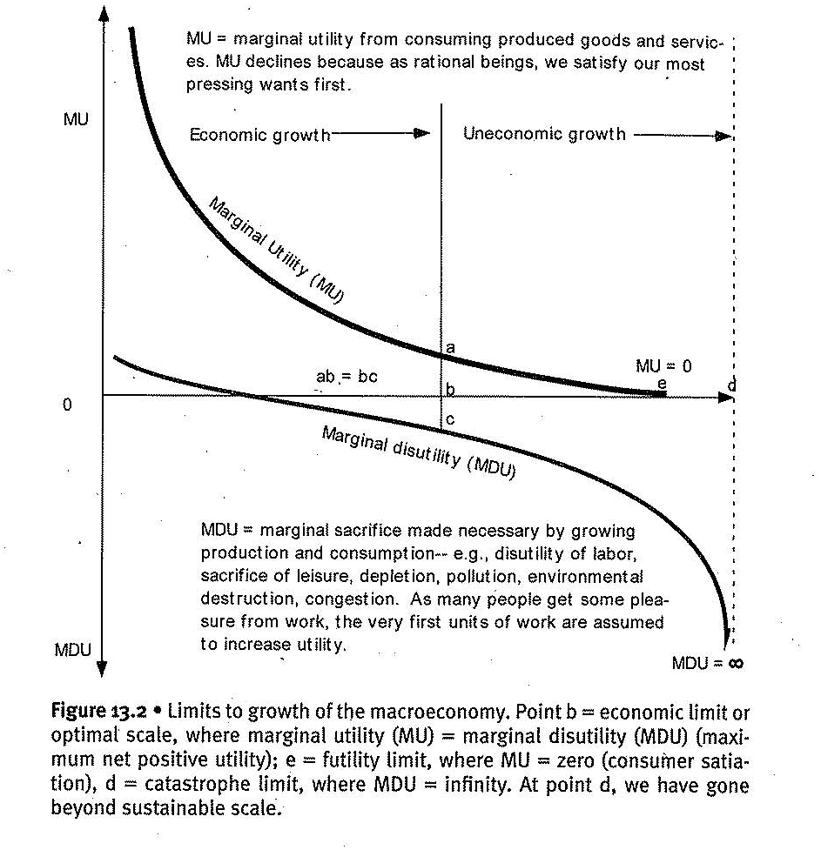

The containing and sustaining ecosystem: the WHOLE
The economic system is a subsystem of the global subsystem and one of the major goals of ecological economics is to determine when the benefits of continued growth in the economic subsystem are outweighed by the increasing opportunity costs of encroaching on the sustaining ecosystem.
In addition to determining when economic growth becomes uneconomic, ecological economists must provide the policies necessary to keep the economy within its ‘optimal’ size range! This document starts with the divisions demanded for understanding scarce resources (biotic & abiotic, stock-flow & fund-services, rival-nonrival, excludable & non-excludable.

Stock-flow and fund-service
In the academic literature, there are many distinct definitions for stocks, flows, funds and services. To make it clear we are discussing the specific definitions given here. Future references will be to stock-flow and fund-service resources
Stock-flow resources
- Are materially transformed into what they produce (material cause)
- Can be used at virtually any rate desired (subject to the availability of fund-service resources required for the transformation), and their productivity is measured by the number of physical units of the product into which they are transformed
- Can be stock-piled
- Are used up, not worn out
Fund-service resources:
- Are not materially transformed into what they produce (efficient cause)
- Can only be used at a given rate, and their productivity is measured as output per unit of time
- Cannot be stock-piled
- Are worn-out, not used up

Excludable & Non-excludable
Excludability is the legal concept that, when enforced, allows an owner to prevent others from using his or her asset.
Examples
Excludable: Ownership of a bicycle, land: An excludable resource is one whose ownership allow the owner to use it while simultaneously denying others that privilege

Non-excludable: A street-light, protection from UV-Light radiation. If there is no feasible institution or technology that could allow one person to deny all other access, we are speaking of a nonexcludable resource.

Rival and non-rival resources

Rivalness is an inherent characteristic of certain resources whereby consumption or use by another person reduces the amount available for everyone else. A rival resource is one whose use by one person precludes its use by another person.
Examples
Rival resources: A pizza (a stock-flow resource) is clearly rival, because if you eat it, it is no longer available for me to eat! A bicycle (a fund-service resource that provides the service of transportation) is also rival because it is worn-out
Non-rivalness: A non-rival resource is one whose use by one person does not affect its use by another: again, the street-light is a good example. If I use the ozone layer to protect from skin-cancer, there is just s match left for you to use for the same purpose. Of course, my use of chlorofuorocarbons may reduce the ozone for both of us but depletion does not come upon usage for some purpose.
Observation: All stock-flow resources are rival and all non-rival goods are a fund-service.
Goods and services provided by the sustaining system:
Clearly, earth supplies an abundance and of abundantly (due to interaction, perhaps) complex resources but we pick eight to describe their fundamental importance to economic policy.
- ABIOTIC RESOURCES
- Fossil fuels. For practical purposes, fossil fuels are a nonrenewable source of low-entropy energy. They are also very important as material building blocks
- Minerals. The earth provides fixed stocks of the basic elements in varying combinations and degrees of purity, which we will refer to hereafter simply as minerals. This is the raw material on which all economic activity and life itself ultimately depends. Rocks in which specific minerals are found in relatively pure from we refer to as specific minerals are found in relatively pure form we refer to as ores. Ores in which minerals are highly concentrated are a nonrenewable source of low-entropy matter. We will refer to mineral resources and fossil fuels together as nonrenewable resources and the first five goods and services in this list as abiotic resources
- Water. The Earth provides a fixed stock of water, of which fresh water is only a miniscule fraction. All life on earth depends on water and human life depends on fresh water
- Land. The earth provides a physical structure to support us that is capable of capturing the solar radiation and the rain that falls upon it. Land as a physical structure, a substrate, or a site has economic properties unrelated to the productivity of the soil, and is thus distinct from land as a source of nutrients and minerals. To capture this distinction, we will refer to land as a physical structure and location as Ricardian land. The quantity and quality of soil available on a given peace of Ricardian land will be grouped with minerals discussed below
- Solar energy. The sustaining system provides solar energy, the ultimate source of low-entropy upon which the entire system depends
- BIOTIC RESOURCES
- Renewable resources. Life is able to harness solar energy to organize water and basic elements into more useful structures (from the human perspective) that we can use as raw materials in the economic process. Only photosynthesizing organisms are capable of achieving this directly, and virtually all other organisms, including humans, depend on these primary producers. These biological resources are traditionally referred to as renewable resources but they are only renewable if extracted more slowly that the rate at which they produce. Clearly species can be exploited to extinction, so as we shall see, biological resources are exhaustible in a way that mineral resources are not.
- Ecosystem services. Living species interact to create complex ecosystems and those ecosystems generate ecosystem functions. When functions are of use to humans, we refer to them as ecosystem services. Many of these ecosystem services are essential to our survival
- Waste absorption. Ecosystems process waste, render it harmless to humans, and, in most cases, again make it available to referred renewable resource stocks as new raw material input. This is really a specific type of ecosystem service, but one whose economic characteristics make it worth classifying on its own!

Abiotic resources
Abiotic resources are fundamentally different from each other, and it is the their even greater dissimilarity from biotic resources that binds them together. Perhaps their most important distinction is that biotic resource are simultaneously stock-flow and fund-service resources that are self-renewing, but human activities can affect their capacity to renew. Abiotic resources are either non-renewable (fossil-fuels) or virtually indestructible (everything else)
Grouping attempted: Fossil fuels and mineral resources are grouped together under the classification of: “non-renewables. Grouping failure: energy from fossil-fuels cannot be recycled while minerals, at least partially, can. Water is the most difficult to classify because of its many uses. Sometimes it’s like mineral resources (used up-then degraded\less useful) while at others (rivers, lakes & streams) it is more similar to biotic resources.

FOSSI FUELS
In 1995 fossil fuels accounted for 85% of our global energy needs:
Crude oil: 38%, Coal: 25%, Gas: 22%
We normally deal with only recoverable reserves for such a discussion, which can be defined as: those for which total extraction costs are less than sales revenues. However fossil fuel prices fluctuate widely! So, another definition, using entropic terms, would be useful: a hydrocarbon is recoverable if there us a net energy gain from extraction, that is: it takes less than a barrel of oil to recover a barrel of oil. This measure must include all the energy costs, including those of exploration, machinery, transportation, decommissioning and so on. While technological change can reduce these, there is a certain irreducible limit to the energy costs of extracting fossil fuels. It takes 9. 8 joules of energy to life 1Kilogram 1 meter and no amount of technology can change that!
On the one hand such energy constraint might be cheaper with new technology, but on the other, the quantity and quality of left reserves might make depending on them, an unfeasible path in the future at a point that cannot be defined.
Still, under wither the economic or the entropic definition the ‘recoverable’ part of the recoverable reserves, might change among countries and companies, with frequent changes often based on political or economic motives.
Of course, meaningful extraction is one component of the debate of use of fossil fuels. Used fuel does not disappear, it must return to the ecosystem as waste: acid rain, global warming, carbon monoxide, heat pollution, and oil spills are unavoidably associated with the use of fossil fuels. If waste products from fossil fuels diminish the ability of the ecosystem to capture energy the indirect costs might be even greater than the direct ones mentioned above. However, these are difficult to measure and, sadly, ignored.
The rea; equation should be:
Net Recoverable Energy From Oil = (Initial total stock of entropically recoverable reserves)
--- (Energy cost of extraction)
--- (loss of solar energy due to loss of capacity to capture)
--- (cost of disasters brought on by oil returning as waste)

Points made:
- Once fossil fuels are used, they are gone forever – they are rival goods
- While fossil fuel stocks are finite, they are stock-flow resource that can be extracted at a set rate… and we got to regulate\manipulate throughput
- Current population depends on them for survival: not only energy; fertilizers, herbicides, pesticides feed 6 bn people
- It is uncertain that we can exchange them with renewables before the negative impacts force us to, or before the resources re depleted

MINERAL RESOURCES

Minerals resources are typically grouped together with fossil fuels in economics textbooks and labelled non-renewable resources. However, there are differences
But let’s start from similarities They are treated like stock-flows, their total stock is finite and, according to the first law of thermodynamics, this imposes a physical limit on their contribution to the material growth of the economy Again It is feasible that technology, like a solar-powered machine that extracts ores, decreases extraction and\or processing costs
As in fossil fuels total stock is not actually known but geologist can assign reasonable probabilities to different estimates. As in fossil fuels there is degree of purity which plays the role of entropy measure as low-entropy fuels are preferred all others, including easiness and cheapness to extract, constant.
Now to the differences: For minerals resources it’s easier to create substitutes. Although we have already developed some substitutes it is still unimaginable to create substitutes for all minerals in order to sustain existing populations or levels of economic production in the absence of specific mineral resources.
. Mineral deposits are sufficiently large and recycling has the potential to become sufficiently efficient (Using polymers from atmospheric CO2 we may be able to achieve 100% recycling) and with careful use, by minimizing waste and substituting where possible, we could sustain a steady state economy for a very long time.
Also, mineral resources are considered as rival goods within a generation but partially nonrival goods between generations depending on how much is extracted and how much is wasted rather than recycled. (fossil fuels are rival in both cases). Then, we can control the level we extract but also the level we waste.

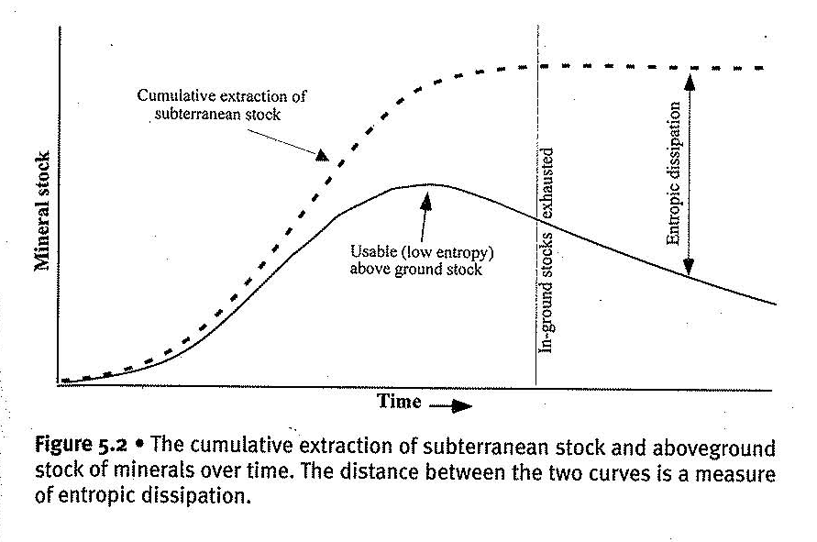
Eventually, stocks become scarcer, the costs of extraction become greater than the benefits and extraction ceases. With 100% recycling the two curves converge. The rate of increase in the aboveground stocks is equal to the net annual mineral extraction minus entropic dissipation; that is aboveground stocks are equal to minerals currently in use plus those that can be recycled

WATER
Earth is a water planet! Though the stock of water is finite, fully 70% of the earth’s surface is covered in water. Freshwater, however, is less abundant, accounting for less than 3% of the total, of which less than one third of 1% is in the form of readily exploitable lakes (0, 009%), rivers (0, 0001%), and accessible groundwater (0, 31%). Another 0, 01% is found in the atmosphere, 0, 31% is deep groundwater, and over 2% is in the polar ice caps and glaciers. Humans are composed mostly of water and in addition to drinking we depend on it for agriculture, industry, hydroelectricity, transportation, recreation, waste disposal and for sustaining the planet’s ecosystem services. Water for different uses has different relevant characteristics that make generalizations difficult.
Water can be a stock-flow resource or a fund-service. Perhaps the best way to look at flowing water is to distinguish it from the hydrologic cycle; The water itself is a stock-flow resource that is rapidly renewed by the hydrologic cycle service (provided solar energy which is stored in the water). However, we store it in dams but that effect is limited and temporary.
When used for transportation, recreation or sustaining all other ecosystems on the planet, water functions as a fund – service resource. Atmospheric moisture, as part of the hydrologic cycle, is essentially a fund-service resource. Like biotic resources, water can be stock-flow and fund-service simultaneously. Unlike biotic resources, however, humans cannot affect the total stock of water in the planet. We can, and do, reduce the stock of usable water, and while it is possible to restore the usability of water there are no substitutes available for its most important uses.
That said, water as a stock-flow is rival, as a fund-service, non-rival and intergenerationally non-rival when considering the ever-going hydrologic cycle

RICARDIAN LAND
Ricardian land, land as physical substrate and location, distinct from its other productive qualities, is also a fund that provides the service of a substrate capable of supporting humans and our infrastructure, and of capturing solar energy and rain. (Ricardian land does not include soil and nutrients in the soil).
A hectare of land may be capable of producing 1000 tons of wheat over 100 years, but one cannot produce the wheat from the same land in an appreciably shorter period, nor would it be possible to accumulate a land’s capacity as a substrate.
The services provided by land are certainly excludable, and at any given point in time, they are also rival. For example, if used for farming, land provides the service of a substrate for crops. If one farmer uses that service, no one else can in the same time period. Economists often use the term ‘depletable’ as a synonym for ‘rival’ but I the case of land suggests that this is inappropriate. Using Ricardian land does not deplete it. While rival within a generation, it is intergenerationally nonrival and absolutely nondepletable

SOLAR ENERGY
Earth shines with 19 trillion tons of oil equivalent per year and it is non-rival and non-excludable but it is not easy to capture for and by humans.
As fossil fuels run out, we will need an alternative source of low entropy to maintain our economy at its current level of thermodynamic disequilibrium. Global energy consumption is about 9 billion toe (tons of oil equivalent – burnt crude oil – per year). Biomass, hydroelectricity, wind, photovoltaics and wave\ocean thermal energy are all forms of solar energy we could potentially capture
While solar energy will bathe the Earth in more energy than humans will ever use, for practical purposes it is a fund-service resource thar arrives at earth’s surface at a fixed rate and cannot be effectively stored for later use. As humans have negligible ability to directly allocate solar energy, the fact that it is essentially nonrival and non-excludable is not particularly important

BIOTIC RESOURCES
Biotic resources include the renewable resources upon which economic production and human life depend, the ecological services that create a habitat capable of supporting human life, and the absorption capacity that keeps us from suffocating in our own waste. As non-renewable resources are exhausted, human society will come to rely more and more on the self-renewing capacity of biotic resources. It is therefore critically important that we understand the nature of these resources.
The basic difference lies in complexity and unpredictability:
Ecosystem structure, the subject of natural resource economics, is about the processes responsible for the sustained reproduction of individuals, population and species are highly complex and poorly understood. What scientists have learned is that when enough separate elements are thrown together, form a complex system where emergent phenomena and nonlinear behaviors occur. When removing 40% of the population of such a system is the effect of removing 20% doubled.
The subject of environmental economics, deals with ecosystem function where populations and species interact with other individuals, populations and species, as well as abiotic resources to create an ecosystem. Ecosystems are extraordinarily complex and dynamic changing over time in inherently unpredictable ways. Ecosystems, the whole as compared to the sum of parts is much more as seen in the ecosystem functions produced. For example: energy transfer, nutrient cycling, gas regulation, climate regulation and hydrologic cycle.
And it is more uncertain as it is more: Estimating stocks of natural resources, or reproductive rates for cultivating species is basically a question of risk (a quantifiable expected value of outcomes with probabilities). Estimating reproductive rates of wild species is a question of uncertainty, since we cannot accurately predict the multitude of factors that affect these reproduction rates. Estimating ecological threshold, conditions beyond which ecosystems may flip into alternative states, is a question of pure uncertainty, or ignorance. (partly because it also has to account for evolutionary and technological change)
An example will illustrate the interdependency of ecosystem structure and functions:
The amazon forest canopy filters about 98% of the sunlight at ground level reducing daytime temperatures. It traps air and insulates increasing night temperatures & It maintains high & constant humidity (created by evapotranspiration and tropical storms which are 50% generated by itself in the case of amazon). Trees absorb the energy of tropical storm, aerate the soil to allow water absorption and slow water flows – all of which prevent soil and nutrients from being washed out of the system. Trees create the microclimate and habitat essential to the soil fauna that help recycle nutrients, facilitating their reabsorption by the system. In a global scale forests trap 90% of solar energy that strikes the canopies. Much of this is released through evapotranspiration and carried high up into the atmosphere, where it is carried into the temperate zones, helping stabilize the global climate. But the feedback loop can turn from positive to negative as for example some computer models predict. Deforestation of 50% of amazon could lead to no rainfall at all during parts of the year. The forest will enter a state of decline and also will be, then, susceptible to fires

RENEWABLE RESOURCES

For simplicity, we can treat biological resource as material stock-flow resources, that is, as elements of ecosystem structure, Like non-renewable resources biological stocks can be extracted as fast as humans desire, but they are capable of reproduction thus they can be studied through a maximum sustainable yield equilibrium as in the graph.

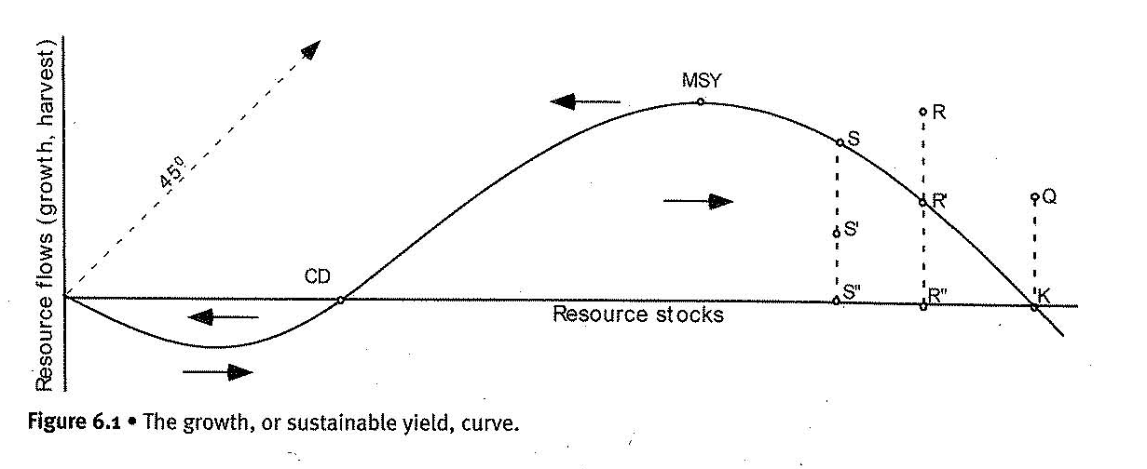
In the graph, X-axis depicts the stock, Y-axis depicts the flow
The 45o or X=Y line is the maximum rate at which we can harvest or Flow=Stock. Actual extraction must lie beneath this line. The curve shows the fast-following relationship: for every population of a resource, there is an associated average rate of population increase, and that increase represents a sustainable harvest that can be removed every year without affecting the base population. If we harvest at R this will reduce stock to S’’ and if a harvest at S’ will allow the stock to increase to R’’.
Carrying capacity K acts as equilibrium where there is just enough food and habitat to maintain the existing population, and the rate of grow in biomass is zero or birth rates=death rates
. If the population is below it, abundant desirable places will be there for fish to lie their eggs and the population will grow in the next period. Or in the case of forest: if we clear some trees, light water and nutrients will be available for the remaining forest. Tha maximum yield thus happens at a specific stock-level!!!
The critical depensation (CD) or minimum viable population is a point where growth rate also equals zero. Below this point population enter into spontaneous decline and enters negative territory where new recruits are needed for the survival of the species. Note that we can still harvest but this will only lead the population to extinction even faster.

A note on practice versus theory. while with careful study and census techniques we can assign reasonable probabilities, thus assessing risk, to population of resource stocks, there is uncertainty in the flows due to reproduction rates being affected by numerous external factors; human impact included. Even carrying capacity deviates from the mean enough to cause problems to researchers.

ECOSYSTEM SERVICES

An ecosystem service is an economic function that has value to humans, Here too lies a lot of uncertainty: before 1970s most people were unaware that the ozone layer played a critical role in making our planet habitable. If we also take into account the tightly interlocking nature of ecosystems, it’s safe to say that humans benefit in some way from almost any ecosystem function.
The main differences among ecosystem stock-flows and ecosystem services are pointed out with examples. A stock of trees can be harvested at any rate chosen by humans and also stockpiled and used at any rate. Also, if you use timber to create a chair the timber will be embodied in it. On the other hand. you cannot control the flow of an ecosystem service of, say, climate stability nor is it embodied in produced crop.

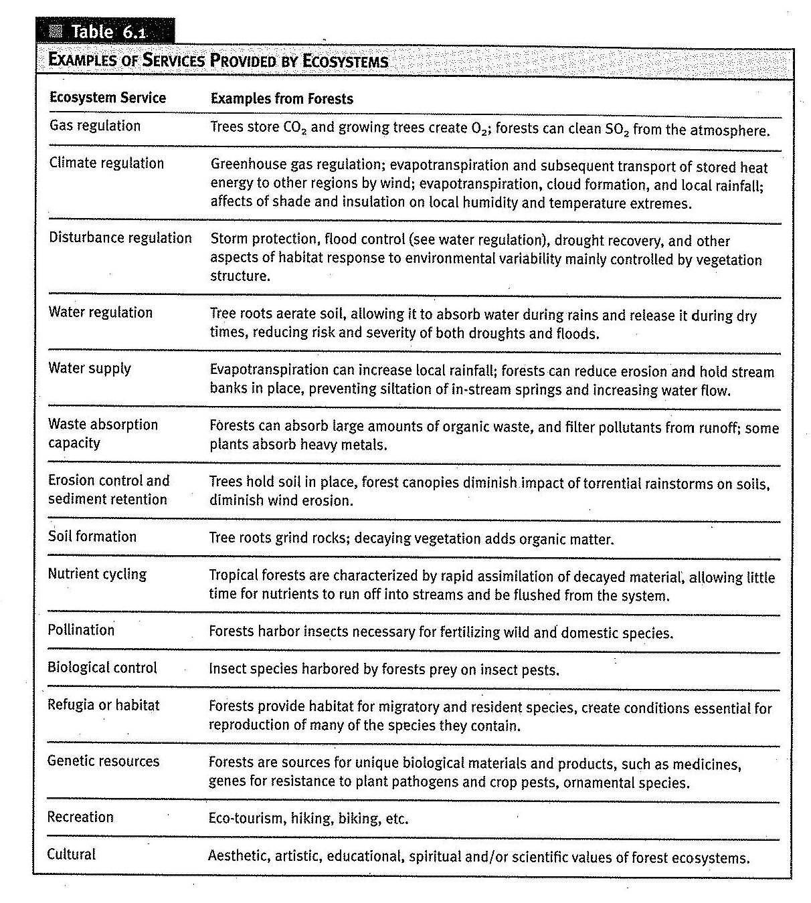
Attention!: While flows are used up, ecosystem services can worn-out and there are no signs of when and why that might happen. We can say with reasonable confidence that the larger and healthier an ecosystem, the more services it is likely to generate but we are anthropocentric and value the ecosystem services produced to humans as more important. For example, an ecosystem service produces by a degraded forest near populated areas as more important to us than a pristine forest further away and Of course we are Ignorant and do not take into account the full effect at regional and global levels
Finally, ecosystem services have no substitutes and are non-rival, we all benefit without a zero-sum effect. Also, when we deplete a stock flow, due to the fact that it creates a fund which in turn creates ecosystem service, we degrade these services too.

WASTE ABSORPION CAPACITY

Until now, with ecosystem services and renewable resources we covered the half part. The laws of thermodynamics ensure that raw materials once used by the economic system do not disappear but instead return to the ecosystem as high entropy waste. They also ensure that the process of producing useful (ordered) products also produces a more than compensating amount of disorder, or waste.
Waste absorption capacity, as a fund-service, occurs at a fixed rate but amount of waste does occur at a rate we choose.
The removal of ecosystem structure also affects the ability of the ecosystem to process waste. If we discharge waste beyond the ecosystem’s capacity to absorb it, we can reduce a rate at which an ecosystem can absorb waste, which makes the waste accumulate even more quickly. In time, the waste builds up will affect other ecosystem functions, though we cannot always predict which services will be affected and when
Extra point made about biotic resources: Since they have no substitutes, they have a particularly large impact on scale Their characteristics are summarized below:
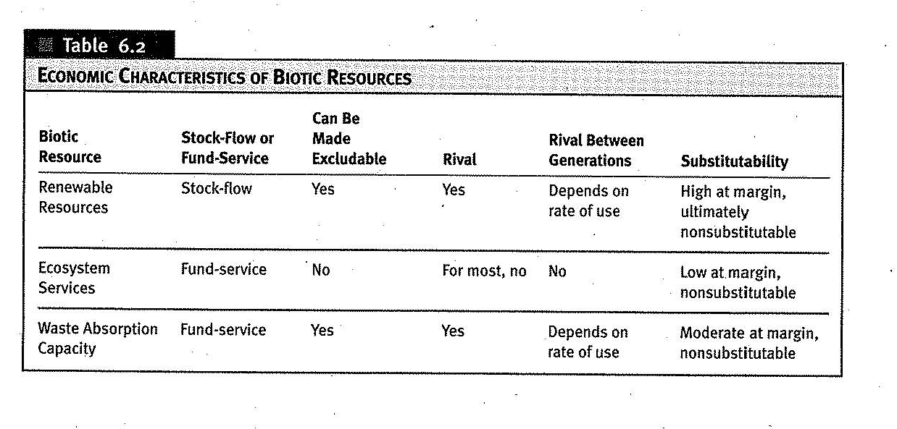

Market failures
Characteristics of market goods
Excludability
An excludable good is one for which exclusive ownership is possible; that is, a person or community must be able to use the good or service in question and prevent others from using it. Excludability is the result for institutions.

Rivalness
A second characteristic that a good or service must have if it is to be efficiently produced and distributed by markets is rivalness. A rival good is one whose use by one person prohibits use of the same unit at the same time by another. Rivalness can be qualitative quantitative or spatial in nature. All stock-flow resources are quantitatively rival

Non-Rival but congestible
There are two types of non-rival goods: Congestible (full roads) and non-congestible (Ozone layer). Congestibility is an issue of scale – as scale increases, as the world becomes fuller, congestion leads some nonrival goods to acquire attributes of rival goods.

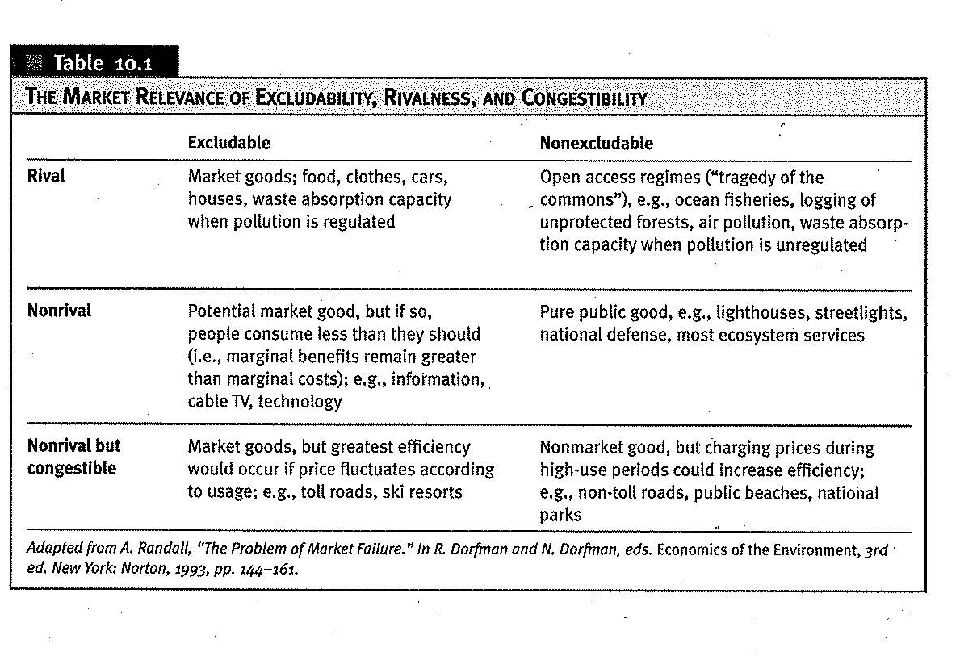

Public goods
Pure public goods (pure is emphatic) are both non-rival and non-excludable. As we move from individual demands to aggregation of all persons’ individual demands or social demand there arise problems. Consider the social demand for a forested park. It costs $100 million and society is willing to pay (preference) $150 million. Therefore, if everyone in the city contributed 2/3s as much money, building the park is worthy. But who is going to undertake that project? Would that be the private sector led by market forces? Assume a corporation builds the park, fences it and charges admission. Knowing that society values the park at $150 million and that in the city has 1 million residents, company decides to charge $15o for a lifetime pass to recoup investment. Problems arise: Not all people value the park the same. All those that value it less will not purchase the pass and investment is proves non-lucrative. Corporation faces a similar dilemma: if it charges entrance one dollar people will not use it as often\at all as if it were free. Thus its value to society would be less.
Consider another example to demonstrate issues in the clash between markets and public goods. global society values (and the numbers are research produced) values ecosystem services of rainforest at $1660\hectare per year. A land-owner kicks of a sharecropper out of his land to produce soybeans that pay 150$ a year, The share cropper colonizes an hectare in the amazon, deforests it for timber to pay in order to fertilize in order to secure a revenue stream of 33$ a year from slash and burn farming. Now on aggregate paying the farmer anything between $150 (for less he would not accept) and $1660 (for more socially unworthy) would be of benefit. But no efficient allocation and/or institutions exist for all non-market goods especially when stakeholders are of different scope (individual, local, national, international, intergenerational).
A third example comes from the price of information. Patents are, in essence, limited-time virtual monopolies of information. They are motivated by partially profits and partially by government transfers or subsidies. It was when they were after a drug for tuberculosis. (70s-80s) when budgets were slashed and finally, they had to pay more after a second wave of casualties.

Externalities

Another important type of market failure is known as an externality. An externality occurs when an activity or transaction by some parties causes an unintended loss or gain in welfare to another party, and no compensation for the change in welfare occurs. If the externality results in a loss of welfare it is a negative externality and if it results in a gain, it is a positive externality. The marginal external cost is the cost to society of a negative externality that results from one or more “unit” of activity by the agent.
The classic example of a negative externality is that of Ronal Coase: a coal-fired utility plant that moves in next door to a laundry service that air-dries its wash!
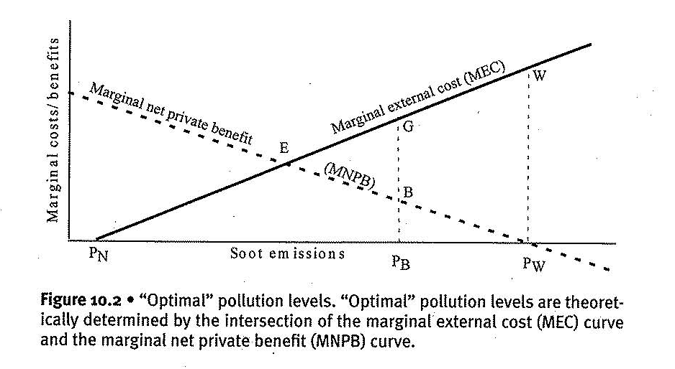
In the most widely cited article ever written on externalities, Coase argues that it doesn’t matter whether the utility is assigned the right to pollute or the laundry is assigned the right to clean air: equilibrium E is likely to be reached t. More on that later.
Economic efficient demands that MNPB=MEC. Let’s assume initially that there are no laws preventing the coal-fired utility from polluting. The utility will produce until MNPB of additional pollution is zero, which occurs at point Pw
However, at pollution level Pw, the laundry service suffers very high costs from the soot – the area EWP_{W} measures the net loss to society. The laundry service could increase its profits by paying the coal utility anything less than P_{W}W to reduce pollution by one unit from point W. The coal utility will increase its profits as long as the laundry service pays it anything at all to reduce pollution (?). If the laundry pays the coal utility to reduce pollution to P_{B}, there is still room for mutually beneficial exchanges. At this point, if the laundry pays any sum less than PbG it will benefit, and if the utility receives any amount greater than PbB it will benefit. The possibility for mutually beneficial exchanges (payments from the laundry service to the coal utility to reduce pollution) continues until we reach point E, where MNPB=MEC and we have achieved a socially efficient outcome in the absence of government intervention. The same result applies if the laundry has the right to clean air, and we start at pollution level Pn. In this case the coal utility will keep paying the laundry service for the right to pollute until reaching point E.
A serious problem arises with the assumptions of the Coase’s theorem:
No transaction costs: if pollution is created at a pin in the map but affects areas at a wider (than national) level transaction fees can be high and include legal fees, the cost of gathering information, located interested parties, the time and cost of bargaining and so on. High transaction costs could justify government intervention. When externalities affect future generation cost the cost is infinite
No wealth effects: A wealth effect example would occur if the laundry earns insufficient profits to pay the utility to decrease pollution and must go out of business when the utility is assigned the right to pollute.
All economic production inevitably generates externalities. Indeed ‘externalities’ is a misnomer, since there is an unbreakable link (throughput) between resource depletion, production and waste emission, so these ‘externalities’ are actually 100% internal to the economic process. But imperfect information, uncertainty and ignorance are such ubiquitous obstacles to market efficiency that they can be considered market failures in their own right: how can we equate Marginal costs and Marginal benefits?

MISSING MARKETS

For a market to function optimally, everyone who would want to produce or consume the goods being marketed must be able to participate. For example, if the Mina Lisa were to be auctioned off and only people from Waco, Texas were allowed to participate, it might not fetch as high a price as it would on the international market. Yet the fact is that future generations to certain resources, such as the ecosystem responsible for generating life-support functions, are inalienable – much like human and political rights where entitlements are decided by efficiency criteria.
As we deplete nonrenewable resources, we could invest a sufficient percentage of the profits in renewable substitutes. For renewable resources we could certify that we balance our harvest to reach and maintain at least the MSY level.
Some extreme opinions may argue: What have future generations ever done for us? Neoclassical economists would most probably react. Yet they still allow for Intertemporal discounting to lead them astray from incorporating non-rival non-excludable goods into their theories and stick to ones for which market efficiency actually works. Their view of the future value of everything might well be based on the formula:
$$NPV=\sum_{t=0}^{T}{\left({Benefits}_{t}-{Costs}_{t}\right)*{ (\frac{1}{1+r})}^{t}}$$

…And, even when the formula is useful, the interest r is chosen with a narrow view of human value being equalized with self-interest.
Aside from future generations markets fail even within a generation because they only balance supply (possibility) and demand (desirability), and they do so under a very restrictive range of assumptions. Among others: goods and resources must be both excludable and rival, market actors must be able to make transactions with zero costs (which would automatically eliminate most transactions), and people must have perfect information concerning all the costs and benefits of every good.

Market failures and abiotic resources

Fossil fuels
Fossil duels are both rival and excludable, and thus can be allocated by market forces. If we ignored resource scarcity (or the future generations) and market failures, the optimal allocation of fossil fuels would simple be the intersection of the demand curve with the supply curve, where the supply curve would equal Marginal Extraction costs (MEX) as depicted in figure 11. 1.
But that would be oversimplification. Second curve MEC in figure 11. 3 includes externalities and curve MUC includes user costs:
User cost is the opportunity cost of nonavailablity of a natural resource at a future date that results from using up the resource today rather than keeping it in its natural state
Marginal user cost is the value of one more unit of the resource in its natural state. In a perfectly competitive economy, marginal user cist would in theory equal the price of a resource minus its marginal extraction cost.
In simple terms a user cost is the value if not extracted. This value increases as the scarcity of the resource increase. However, here too, market failure allows for companies to profit just by paying for extraction costs. (ignoring MEC + MUC)

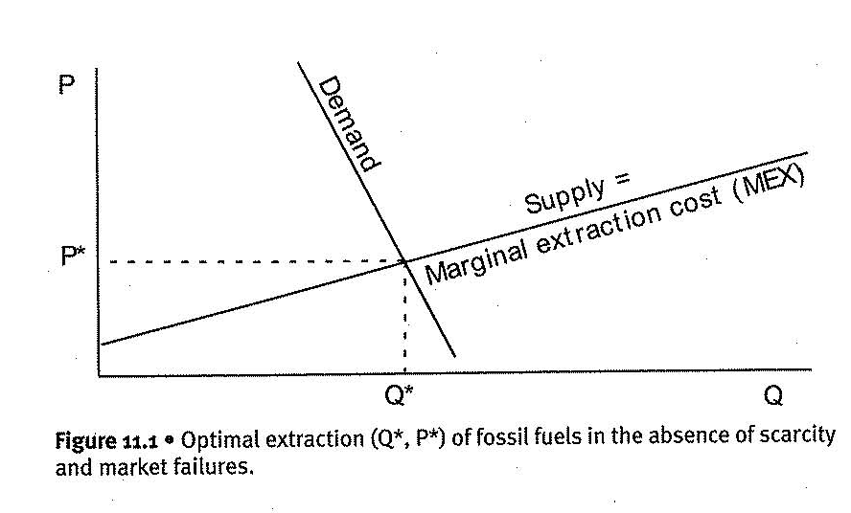

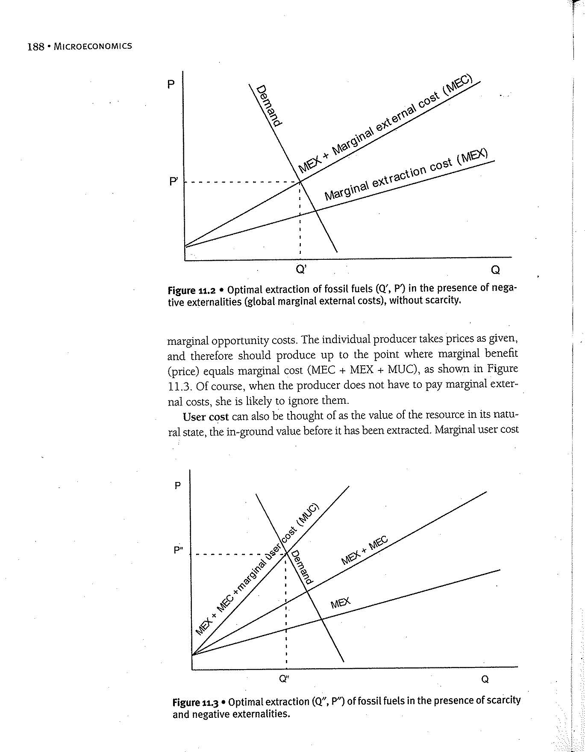

More complexity arises since public bads, associated with fossil fuels, are produced at different levels

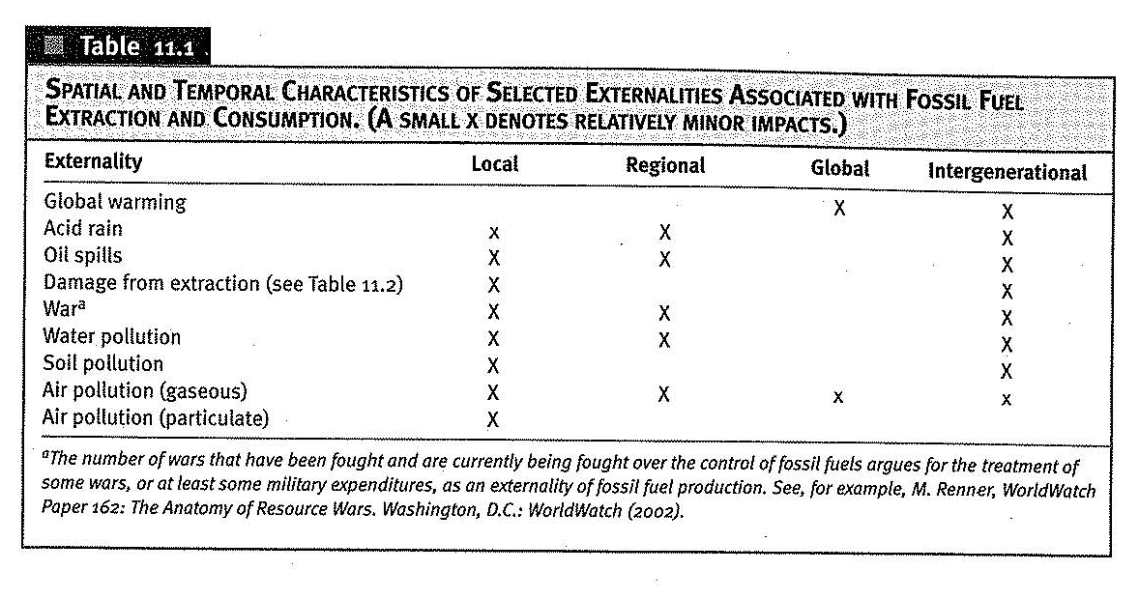

Mineral resources

Mineral resources are also rival and excludable and amenable to market allocation. As in the case of fossil fuels, their production and consumption generate serious externalities. In fact, mining accounts for nearly half of all toxic emissions from industry in some countries, such as the US. As many of these negative externalities are less well known than those associated with fossil fuels use, we have summarized them in table 11. 2.
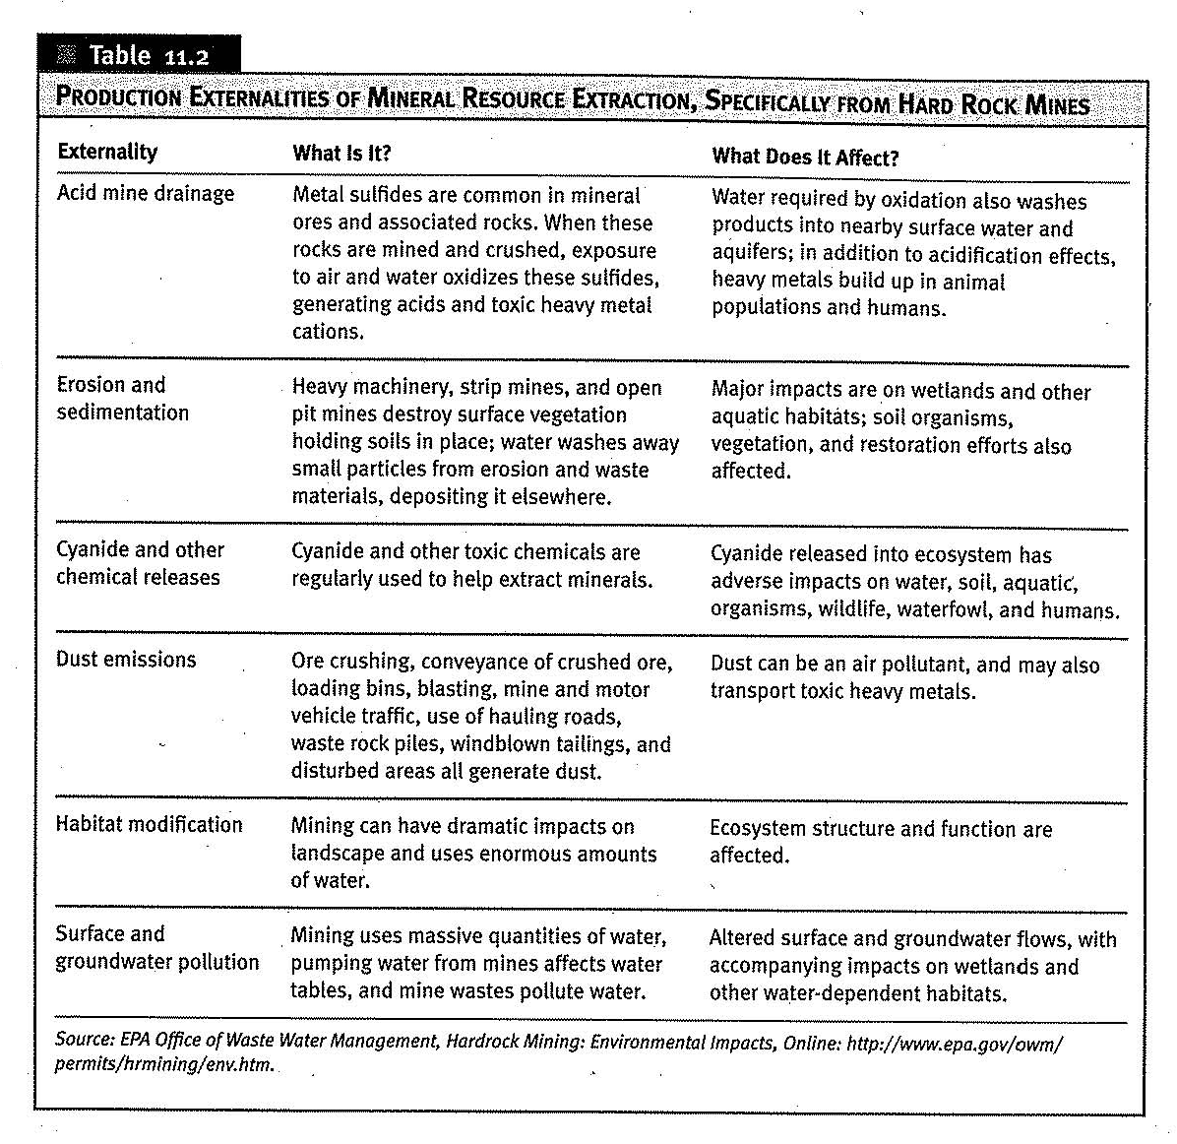

A basic difference though is that:
Mineral resources, to the extent they can be recycled, are rival within a generation, but less so between generations. Thus, if mineral resources were efficiently recycled and had no negative externalities associated with their production and consumption, market allocation could be both intergenerationally efficient and intergenerationally fair.
Prices and scarcity
How do we explain the major anomaly between empirical fact of falling prices of non-renewable resources and the theoretical prediction rising prices? Because prices do not reflect true scarcity
Consider the following facts: Oil discoveries peaked in 1962, production surpassed new discoveries in 1982, and consumption currently (2004) exceeds new discoveries by a factor of two to six. plus, we have been developing more complements than substitutes.
While prices cannot effectively equilibrate unknown in-ground supply with demand, they can equilibrate the available aboveground supply with demand. Available aboveground supply is determined solely by the rate of extraction, which depends on known deposits, existing infrastructure and technology, as well as the resource owner’s decision of how much to extract. Hotelling suggested that a rational producer will limit current production to take advantage of higher prices in future years. However, if real prices are not increasing, the owner has no incentive to leave the fossil fuels in the ground, and would extract the resource as long as marginal extraction cost remains lower than the price, essentially ignoring MUC.
Even if the producer ignores MUC, we would still expect MEC to increase.
For economic reasons, the purest and easiest to mine resources will be mined first. And as we move on new discoveries are expected to mess with that order but the trend cannot be offset. If resource owners are optimists, they believe new discoveries will be made and substitutes invented. This means that their resource will not become scarce and its prices will not go up (and may even go down). Under such circumstances, it makes sense to extract the resources as fast as possible and invest the returns. If the resources are being extracted quickly, above ground supply is large and the price is low. This reduces the incentives for exploration and development of substitutes. The problem is that developing substitutes requires technology, technological advance requires time, and the less warning we have of impending resource exhaustion, the less time there is to develop substitutes. Perversely, then, in a world of optimists, the pessimist is most likely to be correct, and vice versa.

Fresh water
Here we will address the water as a stock-flow resource. Specifically, we address the facts that water is 100% essential to human survival, that it has no substitute, and that water distribution systems generally show substantial economies of scale.
Water, traditionally supplied by the public sector, is a rival good that can be made excludable under most circumstances and therefore technically amenable to market allocation. However, in the name of efficiency, that changes and that has indeed many pitfalls.
When\Where water is abundant, we use it even for unimportant activities. However, since water is essential for survival when scarcer price becomes inelastic. (See diagram below)
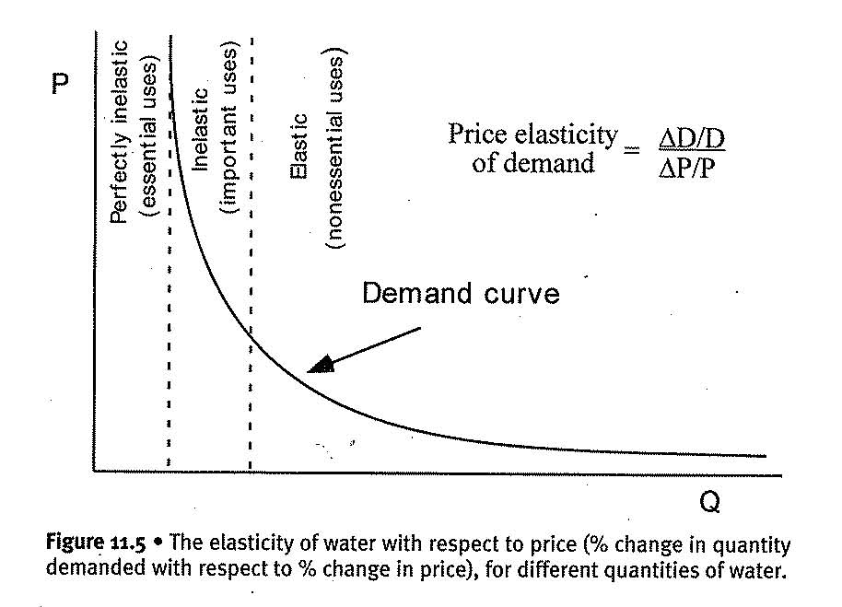
This situation leads to two very serious problems.
‘Perfect ‘ market allocation of water could easily lead to circumstances in which a rich person could pay more to water a lawn than a poor family could pay to water the crops it needs to survive
Efficiency: Markets are rarely perfect, and, in the case of water, they are likely to be less perfect than the most. Providing water requires substantial infrastructure that would be very costly to duplicate. For that reason, it makes sense to have only one provider as in ‘a natural monopoly’ even when privatized. That provider knows that a 10% increase in price will lead to less than a 10% decrease in quantity demanded, leading to higher revenue and lower costs. Plus, end-users can’t get out of the market no matter how inefficient and expensive the provider is. Thus, the rational provider will lean to short-term profits rather and delay needed improvements to the infrastructure. In the end, without competition to drive down prices and no regulation to control costs, the private sector might be less efficient than the public sector, as well as less just.

Ricardian Land
Ricardian land is land simply as a physical space capable of capturing sunshine and rainfall, and not the various productive qualities inherent to the land itself. these- like soil fertility- are classed as ecosystem services. Within a generation, Ricardian land is both rival and excludable, and hence can be allocated by markets. Between generations, it is non-rival, which suggests the market allocation of land might meet the criterion for both efficiency within a generation and fairness between generations.
Before we reach that conclusion, however we must ask: what is that make Ricardian land valuable and thus pinpoint market failures. Land throughout the ages, gained value by people proximity and site connectivity. Government projects like roads and highways may sky rocket the price of land and another government action like marking the land as a protected habitat take away a large chunk of its price (true story). Still there are many investors that seek to purchase Ricardian land for speculative purposes, adding complexity to the price itself.

Solar energy
Primarily for completeness, the final abiotic resource we will consider is the flux of solar energy that continuously warms the earth and turns its biogeochemical cycles. Obviously neither human institution nor human invention can directly change the allocation of sunlight on the earth nor the supply. Indirectly however, market forces can have significant impacts on the scale, distribution and allocation of solar energy.
In terms of scale, human impacts on ecosystems appear to be degrading their capacity to capture solar energy – for example forests sickened by acid rain capture less solar energy than healthy ones. In terms of distribution, land is an essential substrate for the capture of solar energy in most forms other than heat, and markets thus determine indirectly who can utilize the solar energy striking the Earth. Allocation – to what uses sunlight is put- is also determined in part by who owns the it strikes.
In this sense, solar energy is both rival and excludable. Also, something of an allocation issue, land use affects the spatial distribution of solar energy – recall how the evapotransportation from the amazon transports solar energy in the form of heat to the temperate zones. In terms of policy considerations, however these issues can be treated as attributes of externalities of the use of other resources

Market failures and biotic resources

Renewable resource stocks and flows are rival and potentially excludable depending on whether or not institutions exist that can regulate access to them. If depleted at a rate no faster than they regenerate they are nonrival between generations. Unfortunately, unless we explicitly take future generations into account, economic incentive quite likely will lead us to deplete many of these resources faster than they can regenerate, and may eventually threaten them with extinction. What’s more, as we have pointed out repeatedly, the use of renewable resource stocks and flows unavoidably deplete ecosystem funds and services as an externality of their production. This dramatically complicates economic analysis of these resources.
In our earlier discussion of renewable resource stocks and flows, we looked at their physical properties with little ff any discussion of the economics involved.
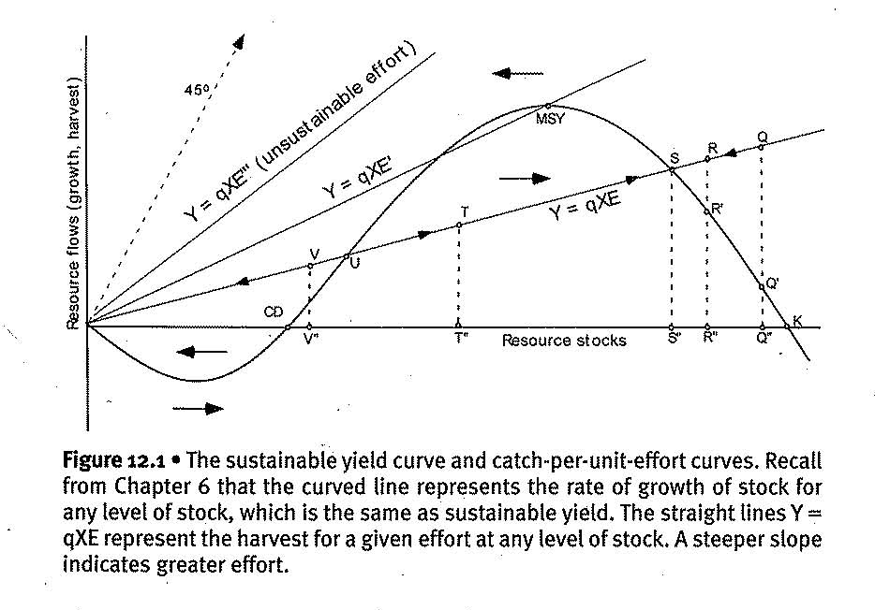
At first glance, it would appear that the goal of economists would simply be to make the resource as productive as possible. If this were the case, we should simply strive to maintain a population that produces the maximum sustainable yield, or MSY. However, this ignores two major issues. First, there are costs to harvesting, which we will call P_{E}E (price of effort times effort, where effort includes all the resources required to harvest a stock), and these costs are likely to increase per unit harvested as the population in question grows smaller. Obviously, the smaller the population of fish that remains, the harder they are to catch. Even for forests, the most accessible timber will be harvested first, and as forest stocks decrease, it will cost more to bring the less accessible stocks to market. Second, and even more important, if we were to consider all resources substitutable, as many economists do, and money is the perfect substitute to any resource, then the economic goal would not be to maximize the sustainable harvest of any specific resource, but rather the monetary sum of annual profits yielded by the resource. But even that is incomplete; a rational individual actually seeks to maximize the monetary sum of discounted future profits.
To simplify analysis, we can assume a linear relationship between effort, stock and harvest, known as the catch-per-unit of effort hypothesis.

Complexity level 0: Natural equilibrium behavior as a response to some harvest Q
Using simple algebra we could assume that Y=qXE where Y is harvest, X is stock and E is effort, and q is a constant we can think of as the ‘ catchability coefficient’. As those of you at all familiar with the math will recognize that this is the equation for a line starting at the origin with slope equal to effort, E. In figure 12. 1, we have drawn lines Y=qXE, Y=qxE’ and Y=qxE’’, where E’’>E’>E. Say the stock in year 0, and effort is E. Our harvest then is Q. Of this harvest Q’’Q’ corresponds to the annual growth for that year, and Q’Q must therefore reduce the stock to R’’. (Note that this figure is not drawn with the same scale on both axes; i.e. resource flows are in smaller units than resource stocks. )At R’’ and effort E, the harvest will be at point R, reducing the stock b R’R. As long as effort remains constant, the process continues until we reach stock S’’ and point S on the sustainable yield curve

Now imagine an external shock, such as El Nino, pushes populations down to I’’ in a given year. As long as effort remains the same, the annual harvest will now be less than the growth increment, or net recruitment and the stock will gradually recover, until we again reach S’’. S is therefore a stable equilibrium point. However, if another El Nino year occurs before the fish population has recovered, it could push the population down to V’’. At V’’ the same effort will lead to a harvest greater than the growth increment, and the population will not recover. Harvest below MSY leads to a higher stock in the following year and any harvest above MSY leads to a lower stock in the following year. The arrows on the diagram illustrate this dynamic. Thus, point U, where the catch per unit effort curve intersects the MSY, is an unstable equilibrium.

Complexity level 1: When we seek to maximize annual profits rather than yield
Suppose the goal is to maximize sustainable annual profits (π) from exploiting the fishery. This requires that we figure out where on the sustainable yield curve profits are maximized. Unfortunately, our graphical analysis using the effort curve does not directly show profit. To analyze the question from the perspective of annual profit is worthwhile and we will require a somewhat different graph:
Figure 12. 2
The axes and the yield curve are the same, except that we multiply the vertical (flow) axis by a constant: P_{F} the price of fish. This converts the yield curve into a total revenue curve (TR) without changing its shape, since we multiply by a constant. Since profit (π) is equal to TR-TC we need to add the total cost curve. If we define effort as all equipment, labor, and other resources that go into fishing, then TC is equal to the amount of effort times the price of effort, and therefore can be derived form a series of catch-per-unit-of-effort curves. We may think of TC as a curve starting at maximum population and rising to the left as more fish are caught, TC will increase as more fish are caught both as a result of stock depletion and as a result of harvesting a larger sustainable yield (at least up to MSY)…But even beyond MSY the TC will probably still rise because stocks have become so sparse that the fish have become hard to find.
Focusing on the flow dimension only, Π=TR-TC and π is located at N₁ where MR=MC (MR being the tangent line to TR). Remember that we have left the stock dimension out of concept of total revenue – we are analyzing profit as a sustainable flow, not as the result of unsustainable stock reduction. Some stock reduction is necessary to arrive at the profit maximizing stock, but ignore that for now; just assume for now that the stock reducing, one – time catch of fish are thrown away.
In figure 12. 2 we can see that the maximization of annual profit AB occurs at N1, which is larger than the stock corresponding to MSY. In other words, in this analysis the profit-maximizing capitalist will not even reach MSY, much less drive the population into extinction! If total costs were zero or constant marginal costs would be zero and profit maximization would dictate that we harvest at MSY where the MR = 0
Complexity level 2: More than one decision makers we seek to maximize annual profits
We have assumed a single capitalist exploiting the fishery, a single owner or decision maker. Instead of private property with excludability, suppose the fishery were open access, as most are. Under an open access regime (in which you’ll recall the resource is nonexcludable), new fishermen will enter as long as there are profits to be made. New entrants will push the stock down to N₂ at which π=zero or TR=TC. At N₂ many more resources go into fishing, but the sustainable catch is less than at N₁ and no one makes a profit (perfect competition)
Curve TC’ depicts lower harvest costs, which might come about from a technological advance such as sonar devices for locating fish schools. At these lower costs, in an open access fishery it would be profitable for new fishermen to keep entering the fishery even after harvests become unsustainable. This is the case where tragedy of the commons\open access resources may well lead to extinction, and may be a realistic depiction of what was happening in north Atlantic cod and many whale populations before regulation become
Complexity level 2: When we seek to maximize Net present value and when profits can be re-invested.
Returning to the higher cost scenario (TC), suppose that we make sure that there is a single owner, not open access. Are we then sure that we will end up at N₂? Unfortunately, not, because of the troublesome issue we swept under the rig initially. What happens to those fish that are part of the stock reduction rather than the annual recruitment? They are not thrown away, and their number is large relative to annual growth. Those fish are sold. Stock reduction fish have the advantage of being available now – you don’t have to wait for them to be hatched and grow. But the more you reduce the stock of fish today, the fewer fish you will have tomorrow, and the more difficult it would be to catch those fish. The population of fish is like the proverbial goose that lays golden eggs in perpetuity. Surely, no rational capitalist would give such a productive goose. Or would she?
If the capitalist wanted to maximize the sum of golden eggs from now till the end of time, the obviously she would not kill the goose. But the goose also has a liquidation value as a cooked goose. Suppose the capitalist could kill the goose, cook it, and sell it for a sum of money, which when put in the bank at the going interest rate would yield an annual sum greater than the value of the golden eggs? Then it’s goodbye goose, hello bank! The population growth rate of the goose (it’s egg-producing fecundity) is in direct competition with the interest rate, the ‘fecundity’ of money. Neo-classical economists argue that money itself may have no reproductive organs, but it is a surrogate for many other things that can reproduce, and on average those other things can reproduce faster than the goose. So, the goose-killing, re-investing capitalist has converted a slow-growing asset into a fast-growing one, and we are all therefore better off. According to economists, cooking the goose in this case maximizes Net Present Value – the value to us today of all cost and benefit streams from now into the future. Economists calculate NPV by using a discount factor to give less weight to costs and benefits the farther in the future they occur.
Let’s take the story a bit further as a thought experiment. Suppose an economy consists only of renewable resources. The interest rate is equal to some weighted average of the growth rates of all renewable resource populations. Everything that grows more slowly than the average (the interest rate) is a candidate for extinction (i.e. if timber grows at a 3. 5% rate and interest rate is 7% as is on average during the last 70 years). But something is always below average. When the below average is eliminated, what happens to the average in the next period? It goes up of course. The tendency, it seems, would be to end up with only the fastest growing species. Bio diversity would entirely disappear. In a world to which everything is fungible that would not matter. We could all eat algae, if that were the fastest growing species!
But we have forgotten prices. Surely prices would rise as particular slow-growing species became scarce and the rising price would compensate for low biological growth rate, so that the value of the species would grow at a rate equal to rate of interest before it became extinct. Yes, but remember that when the price goes up, the price of the existing stock rises as well as the price of the flow of recruits. As the price increases, the incentive to liquidate the now more valuable remaining stock rises, along with the incentive to reduce current offtake to allow an increase in the more valuable new recruits. The bluefin tuna is an excellent example of this argument. In 2001, a single 444-pound bluefin tuna sold in japan for nearly 175000$, or #95/lb. Although this was an anomaly, restaurants in Japan regularly pay up to $100\lb. for a blue fin tuna. Admittedly, this occurs under a regime of imperfect property rights, but how confident are you that private ownership of the blue fin would solve the problem? The higher price means larger liquidation value, as well as higher future revenue from new tuna
How do we decide whether or not to harvest a (marginal) ton of fish that if left in the water reproduces (giving us a flow of golden eggs) and if harvested (giving us a cooked goose) yields interest on the profit?
The neo-classical approach is to ask: What are all the opportunity costs of harvesting the fish today? Obviously if we harvest the fish today, that some ton of fish is not there to harvest tomorrow. Unlike oil and iron, however, we lose not only the opportunity to harvest that ton of fish, but also the offspring of those fish would have had, as well as the increase in biomass they would have experienced, if left in the water. In addition, as the economy grows, people demand more fish and growing human populations further increase the demand for fish. Greater demand means a higher price, and we lose that additional profit if we harvest today. Moreover, if we leave the fish in the water, they will reproduce, and the greater population means that it will be cheaper and hence more profitable to catch a ton of fish next period that this period.
In contrast, the benefit of catching the fish this period rather than the next is that the profits from their harvest can be invested that is the opportunity cost of not catching the fish is the money forgone from not being able to invest the profits from that ton of fish between this period and the next. As we have harvest more and more fish, the growth rate (the annual increase in biomass/total biomass) increases, so the marginal costs of harvesting are increasing.
The economist will therefore favor harvesting as long as the marginal benefits of catching then next ton of fish are greater than marginal costs, and will stop when they are equal. The tricky thing about it is the decision is that when we consume more stock today in exchange for less stock and less yield tomorrow, it is not just tomorrow, but in perpetuity. We must compare a one-time benefit with a perpetual loss. As we mentioned above, economists address this problem rather unsatisfactorily by the financial convention of discounting and present value maximization.

Complexity level 3: Including resource funds and services produced as renewables are consumed
While natural resource stocks and flows have some characteristics of market goods, the services generated by funds typically do not. Such services are generally nonexcludable and for many, no feasible institutions or technologies could make them excludable. Thus, free markets will not produce them. They are also nonrival and non-congestible, and selling them in the market would not equate marginal costs with marginal benefits. To incorporate the services’ value (total external cost) to costs we produce the curve TSC for Total social cost adding services on top of Total Private Costs. We observe that when we do that the CD (for critical depensation cost) is never reached as total external costs rise exponentially while private costs rise linearly.
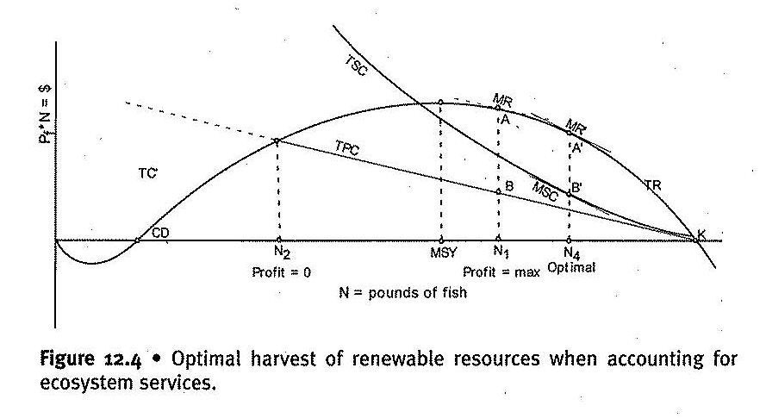
All economic production incurs externalities. All externalities must be incorporated and their value fluctuates with changes in quantity supplied and resulting scarcity. Not to mention risks, uncertainties and most common than not, ignorance. Unless we recognize the values of both the fund-service and the stock-flow, resource extraction rates will not be optimal. Figure 12. 5 summarizes the discussion of optimal stocks and harvests from renewable resources and figure 12. 6 introduces the concept of natural dividend which can be thought of as the value of the resource in the ground (or sea). While the natural dividend typically accrues to the owner of the resource, it is a purely unearned profit from production. To whom should the dividend belong? That is a political decision, more in the realm of distribution than efficient allocation.

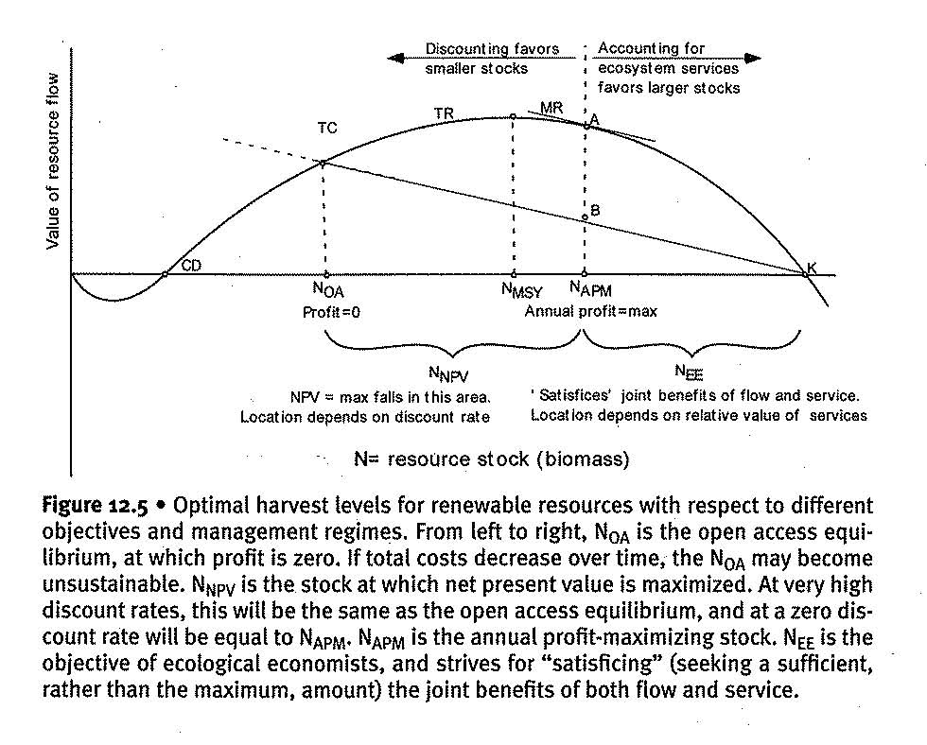
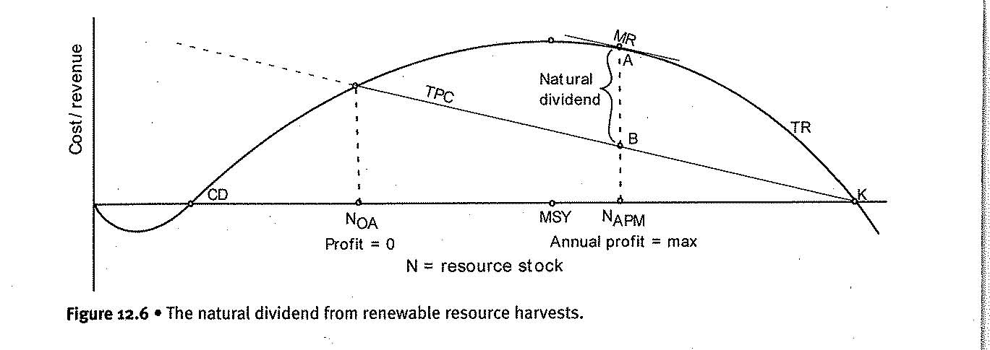

Waste absorption capacity
Waste absorption capacity is the ability of the ecosystem to absorb and process pollution; a given flow of waste and it is a rival good: If I dispose my sewage in a wetland, there is less capacity subsequently for that wetland to process someone else’s wastes. Countries are trying to create institutions that make waste absorption capacity an excludable good. These can range from regulation that directly limit industrial emissions to mandatory catalytic converters in cars, to tradeable emissions permits. Tradable permits and quotas for pollution essentially make waste absorption capacity a private good but there are complications: Markets are widely extolled because they allow individual to choose what she produces and consumes so that her marginal benefit equals her marginal costs. Pollution, however, affects public goods, and all individuals must consume the same amount. It would be impossible to create a system in which each individual was paid by the polluter according to his own dislike of pollution
We have to recognize that waste absorption capacity is a dynamic process. If the waste flow exceeds the waste absorption capacity then waste will accumulate. As waste accumulates the ecosystem becomes less able to assimilate it, leading to even more rapid accumulation. Thus, in a dynamic analysis if the flow of waste into an ecosystem exceeds the ability of the ecosystem to assimilate that waste, the waste will build up indefinitely until virtually all services generated by the biotic processes in that ecosystem collapse. The system will thereafter be able to process only negligible amounts of waste.
Figure 12. 7 is an appropriately modified version of the analysis of externalities from Figure 10.2. Note that economic output and waste output are measured in the same axis in recognition of the laws of thermodynamics, In reality, the relationship is not as fixed as figure 12.7 indicates; many technologies are available for producing different goods, some of which generate less pollution than others, though for any given technology the relationship will be fixed.
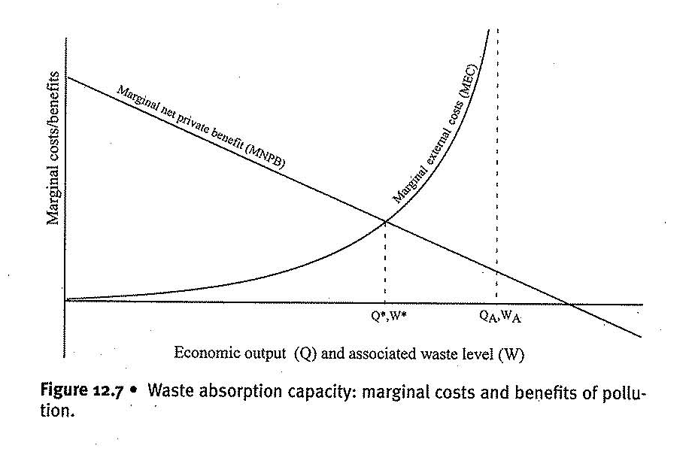
We assume here that the economic output under consideration is not essential – either substitute products and processes are readily available, or the good itself is simply not that important to human quality of life. Chlorine-bleached paper from wood pulp is a good example. Unbleached paper from kenal or hemp are excellent substitutes, and paper itself is important, but not essential to life. Among the many wasted emitted by paper mills are organochlorines, and paper mills are the largest emitter o organochlorines into the water supply. Organochlorines resist biodegradation, and hence the waste absorption capacity for these substance is quite small; it is indicated by the perpendicular point Q_{A}, W_{A} in figure 12. 7 where cost is infinite according to exponential MEC curve.
Organochlorines include some of the most toxic substances known, such as dioxins, which readily accumulate in the environment and in animals including humans. Health problems associated with dioxins include cancer, immune system disorders and developmental problems in children and fetuses. We assume that surpassing the waste absorption capacity for organochlorines for extended periods could make the affected areas essentially uninhabitable for humans, and on our crowded planet. This is an unacceptable high cost.
Complexity accumulates also when MNPB (benefits of pollution is production of goods and services) is shifted upwards. Depending on the population level and the level of economic activity MNPB may become zero before or after reaching web absorption capacity of the environment. The more full our planet becomes – that is the larger the scale – the more likely that MNPB will still be positive when we reach the vertical part of MEC. Why? Goods and services are characterized by diminishing marginal utility. This means that for a given amount of goods, more people imply lower per-capita consumption, and hence higher utility from each unit consumed.

